
Application Interface
-------------------------------------------------------------------------------------
Activate the virtual environment (source venv/bin/activate) and start the server with the command sh runserver.sh in your terminal, for activating the web application.
1. Login to https://aiml-sandbox1.talentsprint.com/audio_recorder/. Enter the Group Id given to you to by the mentors. Screenshot below:
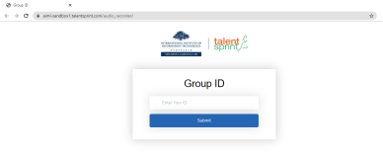
2. After entering your Group Id click on the submit button. It will redirect you to the below screen.
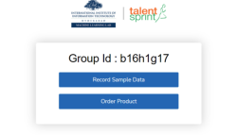
3. Record Sample Data will help you to record the voice samples. If you click on the Record Sample Data it will take you to the below screen.
1
COPYRIGHT © TALENTSPRINT,2021. ALL RIGHTS RESERVED.

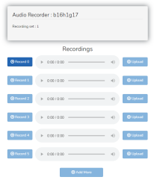
Once you click on the Record 0 button it will turn to “Green” 1 second to record your voice and you can play to check whether the recorded voice is successfully taken or not. You can click on the upload button for uploading. After Recording Record 0 only Record 1 button will be enabled. Below is the screen it looks like once you record all the samples. You can record your samples multiple times by clicking on the respective Record button and it will take the last recorded sample for that respective Record. Once uploaded you can’t make any changes.
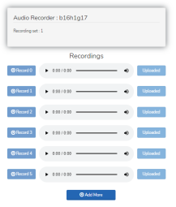
2
COPYRIGHT © TALENTSPRINT,2021. ALL RIGHTS RESERVED.

4. Once you click on Add More button it will redirect you to the below screen to record the new set of data.
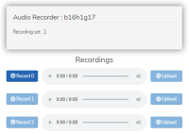
5. Once you click on the Order Product button it will take you to the screen below. You have to record the samples according to the order number given for the particular item.
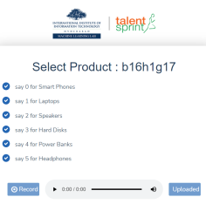
6. Once you click on Record the button turns to Green and it will record the number that you have uttered and then click on upload it will give you the number and the corresponding item. It will look like the below screen
3
COPYRIGHT © TALENTSPRINT,2021. ALL RIGHTS RESERVED.

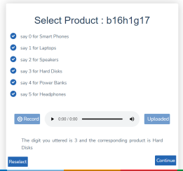
7. If the predicted number is incorrect you can re-record and upload your voice by clicking on the button Reselect.
8. If you click on the continue button it will take you to select the store page. You have to utter the number that you want to record and click on upload it will give you the number and the corresponding serving. The screen looks like below:
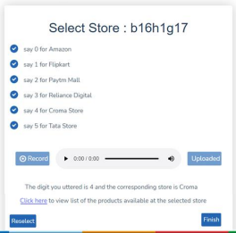
4
COPYRIGHT © TALENTSPRINT,2021. ALL RIGHTS RESERVED.

9. Click on the provided hyperlink to launch the external website based on the provided preferences
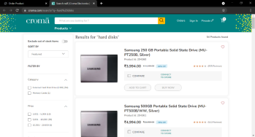
10. Click on Finish button to end the existing session and start a new session, it will again take you to the Select Product page like above and repeat the same process again.
5
COPYRIGHT © TALENTSPRINT,2021. ALL RIGHTS RESERVED.

